KaggleRawData:https://www.kaggle.com/datasets/yusufdelikkaya/online-sales-dataset
DataCleaning:https://drive.google.com/drive/folders/1UjRB1aE-OIvMaIf6R_b4EJwVnlXVaFrC
PowerBI:https://drive.google.com/drive/folders/1UjRB1aE-OIvMaIf6R_b4EJwVnlXVaFrC

ONLINE SALES DATA ANALYSIS AND PERFORMANCE INSIGHTS (2024-2025)
The dataset comprises anonymized data on online sales transactions, capturing various aspects of product purchases, customer details, and order characteristics. This dataset can be utilized for analysing sales trends, customer purchase behaviour, and order management in e-commerce. It can aid in understanding the impact of discounts, payment methods, and shipment providers on sales performance and customer satisfaction. This dataset can be utilized for analysing sales performance, customer purchasing patterns, and operational efficiency in order management.
PROJECT OBJECTIVES:
- SUM OF UNIT PRICE BY CATEGORY
The price ups and down based on category, make calculation entire category product.

- SUM OF SHIPPING COST BY DESCRIPTION AND RETURNED STATUS
The description is like Category in online sale data created by returned status it will clear us the product is return from customer or not and which is most returned product from customer.
3.SUM OF DISCOUNT BY CATEGORY
Every product is valued by discount, which one is given more discount by product.
4.SUM OF SHIPPING COST BY DESCRIPTION
AS description-based shipping cost calculated it shows most trending sales in the online.
DOMAIN SOURCE:
Kaggle data portal & online sale data in different country (2024-2025)
DOMAIN: Online Sales.
PROBLEM STATEMENT:
- Clean and preprocess sales data to handle missing values, duplicates, and inconsistencies
- Analyse sales trends over time (daily, monthly, yearly)
- Identify top-performing and underperforming products and categories
- Evaluate customer purchasing behaviour and repeat purchase patterns
- Assess regional performance and demand fluctuations
- Measure key metrics such as total revenue, average order value, conversion trends, and profit margins

TOOLS & TECHNOLOGIES
MICROSOFT EXCEL:
Excel is basically a Remove Duplicates,Text to Columns,Find & Replace,TRIM, CLEAN, PROPER,Handling missing values,Data Validation (dropdowns, rules) From raw data.
POWER BI:
A power bi doing raw data turns into stories connect to excel/csv files segregate to power query, data modelling, Dax functions, data visualizations, dashboard &report.
ONLINE SALES DATA ANALYSIS DASHBOARD AND INSIGHTS:
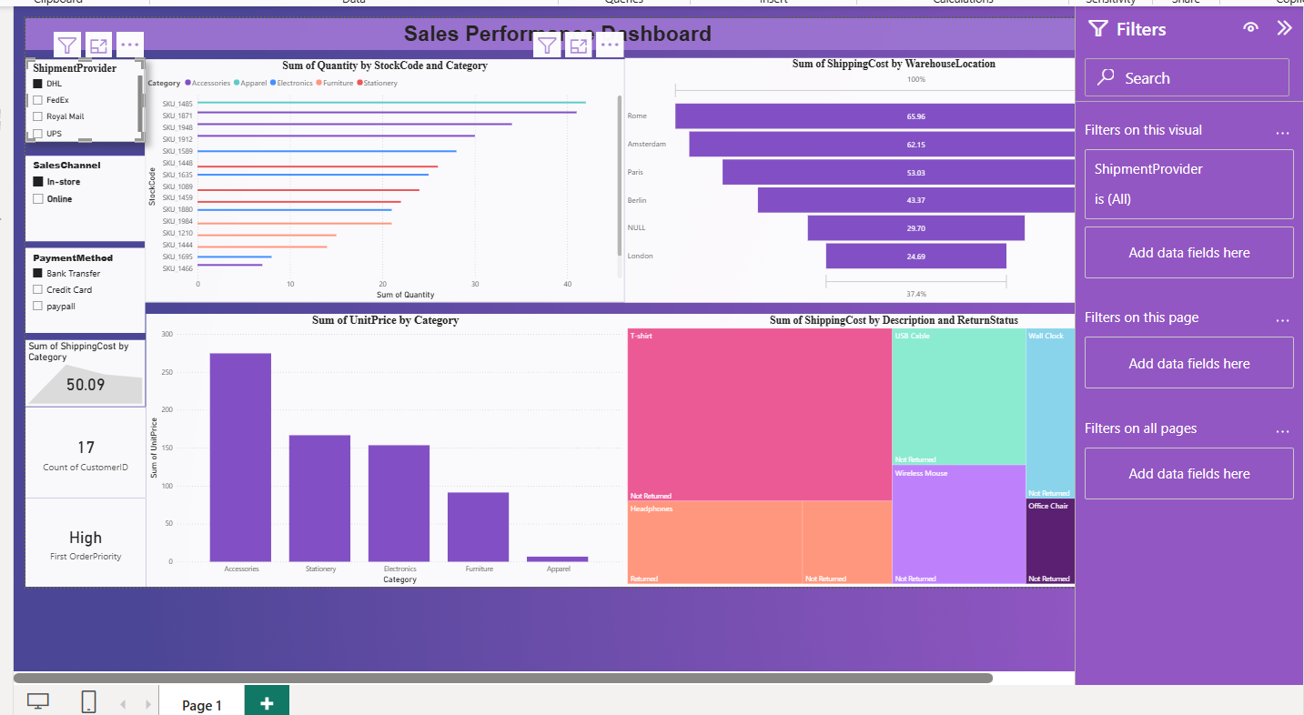
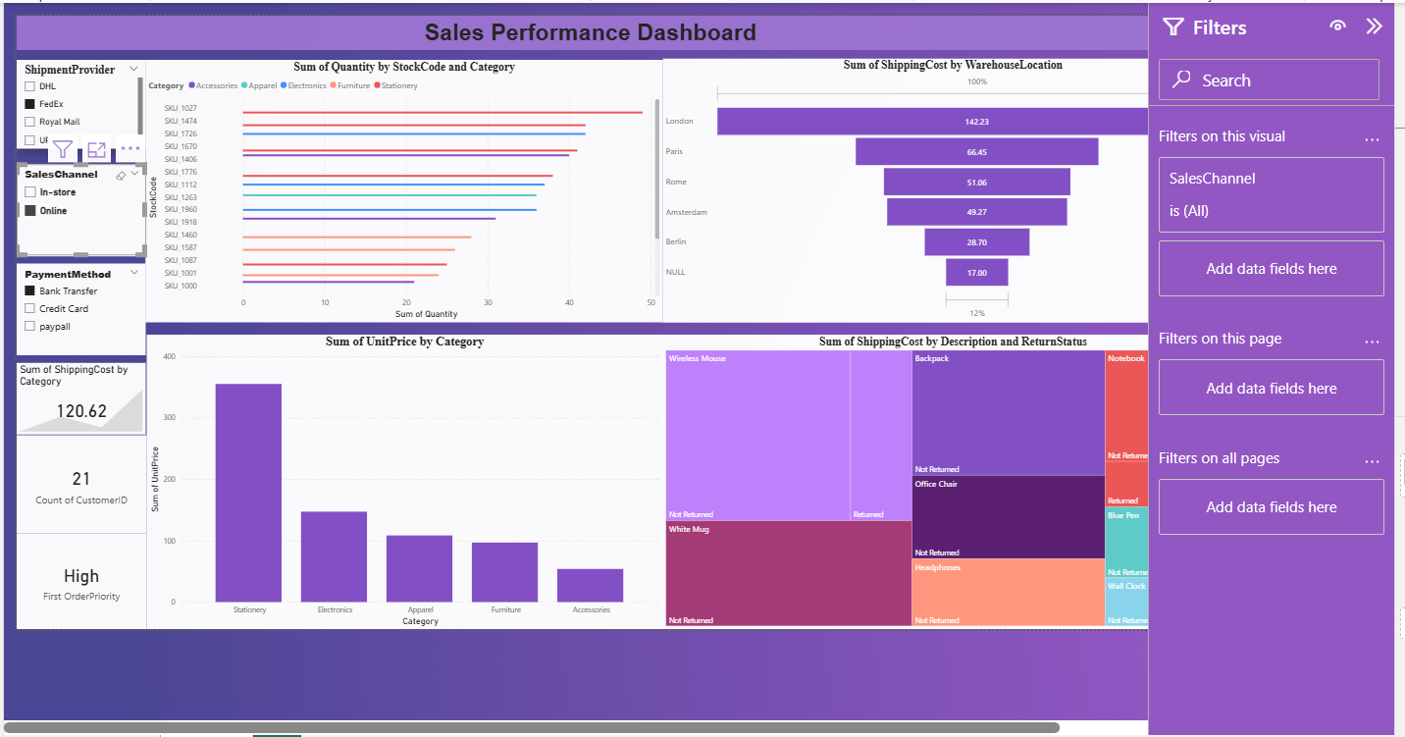

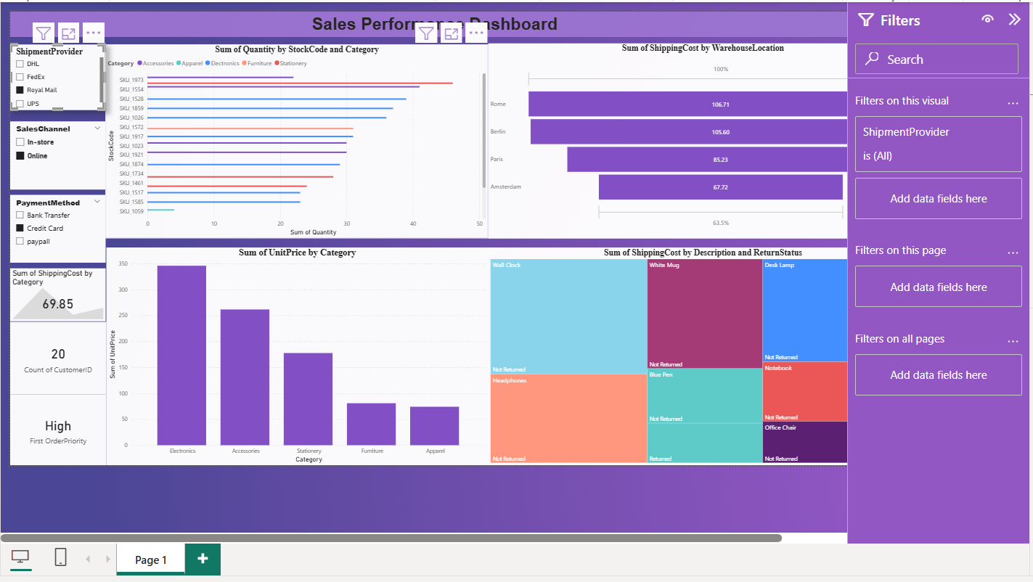

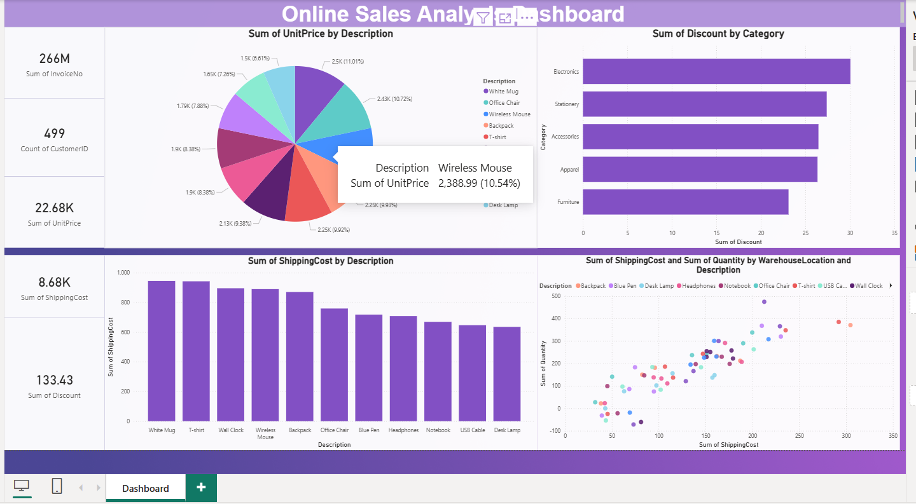

CONCLUTIONS:
Online sales show seasonal spikes during festivals, holidays, and discount events. Revenue growth is not always linear—short campaigns often outperform long promotions. Timing and campaign planning matter more than constant discounts. A small percentage of customers contribute to a large share of total revenue. Repeat customers have a higher average order value (AOV) than first-time buyers. Retention strategies are more profitable than acquiring new users alone. A limited number of products generate the majority of sales volume. Low-selling products increase inventory costs without adding much revenue. Focus inventory and marketing on top-performing products. Heavy discounts increase order volume but reduce profit margins. Moderate discounts often lead to better profitability than aggressive price cuts. Discount optimization is critical for sustainable growth.

